

Contents

Authors 2

Scope 2

Last Major Revision 2

Assumptions 3

Key Considerations 3

Regulatory framework 4

Species Susceptibility And Pet To Pet Transmission 4

Strategies To Maintain Physical Distancing 4

Transmission of infection: Snapshot 4

Phases of Resumption and Expansion 7

Contingency Planning for Fall 2020 in Ontario 8

Phases and Subphases 14

Overarching Process And Protocol Adjustments 15

Roadmap Planning Table: Overarching Changes 16

Shelter Services and Programs – Phases and Stages 18

Phase 1: Essential Services – Keep Open to Fullest Extent Possible 18

Phase 2: Step-Wise Service Resumption or Contraction Based On Priority: Risk 19

Phase 2A: High Priority, Low Risk 19

Phase 2B: High/Medium Priority, High/Medium Risk 20

Phase 2C: High Priority, High Risk 21

Phase 2D: Medium Priority, Medium/High Risk 21

Phase 2E: Low Priority, Medium/High Risk 22

Phase 3: Resilience 22

Appendix 1: NACA Recommendations For Continued Modified Operations Due to COVID-19 23

Appendix 2: College of Veterinarians of Ontario - Risk-Based Approach To Decision-Making In The COVID-19 Environment 25

Appendix 3: Ontario Veterinary Medical Association COVID-19 Guide for Practices (April 17) 26

Appendix 4: Owner Contact Guidelines 28

Appendix 5: CVO Guidance For Ontario Veterinarians – Selected CVO Updates 29

Appendix 6: Spay/Neuter Self-Assessment Checklist 31

Appendix 7: Example Of A Morning Check-List 32

Appendix 8: Staff Survey - Example 33

Appendix 9: Examples Of Signage 34

Appendix 10: FAQ For Clients (Partially Reproduced Below) 36

Appendix 11: Suggested Approach to Use of PPE. 37

Appendix 12: Building A Plan To Re-Open 38

Appendix 13: The Future Is Here: Ten Steps Shelters Can Take Now To Build Better Animal Services 39

Appendix 14: Provincial Government Lifts Urgent Care Provision For Veterinary Services (May 14) 40

Appendix 15: Key Points - Ontario Workplace Safety and Prevention Services Guidance for Veterinary Clinics 41

Appendix 16: Toronto’s COVID-19 Status and Risks 43

Key Resources 45

# Authors

Linda Jacobson BVSc MMedVet PhD, Senior Manager, Shelter Medicine Advancement

Karen Ward DVM ASPCA Shelter Fellow, Chief Veterinary Officer

Phil Nichols RVT CAWA, Chief Operating Officer

# Scope

* Create and maintain a roadmap for recovery
* Define prerequisites for implementation of each Phase and Subphase
* Monitor progress

# Last Major Revision

Sep 29, 2020 – for the Fall wave

# Assumptions

1. The pandemic will persist at least for months and more likely a year or longer, necessitating medium- to long-term changes in mindset and operations.
2. There will be advances and retreats as infection rates rise and fall, necessitating a nimble, flexible and adaptable strategy.
3. There will be rising demand for PPE as businesses re-open.
4. Infection risk is a product of exposure and time and is highest in confined spaces.
5. Anyone might be contagious, whether they are symptomatic or not.
6. Human error will put people at risk without behaviour change and robust, updated infection control systems. These will have unavoidable budgetary implications.
7. All on-site services will need to be scaled back for foreseeable future, requiring a more streamlined and flexible approach to operations in order to help the maximum number of animals possible.
8. New systems that allow contactless and remote service delivery must be maintained for the foreseeable future.

# Key Considerations

1. On-site staffing capacity is based on the ability to maintain physical distancing as well as keep staff in reserve if teams are isolated/quarantined. All other on-site capacities to follow on-site staffing capacity.
2. The number of animals housed in the building must remain as low as possible.
3. Physical distancing is the single most important way to prevent human infections.
4. Required PPE must be used consistently and correctly, while avoiding unnecessary use of PPE and reusing materials when possible.
5. On-site processes will be considerably limited and slower than normal because of the need for physical distancing – it is therefore **imperative** to maximize efficiency by streamlining processes and quickly adopting appropriate technology.
6. There is no need to invent the entire wheel, though some reinvention will be needed by each organization. We have quoted many sources here and should consult shelters further down the path and emergency clinics that have maintained operations throughout.
7. Geographic considerations (higher infection rates in Toronto and the GTA) mean that we should be cautious about expansion of services and not feel pressured to reopen services too quickly. New infections in Toronto are stable but not yet consistently decreasing.

# Regulatory framework

* Ontario Occupational Health and Safety Act
* Emergency Measures and Civil Protection Act (EMCPA)
* Directives and guidelines from the Ontario Chief Medical Officer of Health and Ministry of Health
* Veterinarians’ Act, directives from the College of Veterinarians of Ontario and guidelines from the OVMA and CVMA.

# Species Susceptibility And Pet To Pet Transmission

Humans >>>>>>>>>>>>>>>>> ferrets > hamsters > cats >> dogs

It’s important to be aware of zoonotic disease risks but not to overstate or overinterpret them. This would result in a distraction, when focus is paramount.

# Strategies To Maintain Physical Distancing

* Work off-site
* Virtual services and processes
* Curbside transfer
* Limit numbers of people in the building
* Plan and prepare beforehand e.g. medical procedures

# Transmission of infection: Snapshot

SARS-CoV-2 is transmitted primarily via aerosol droplets during close, unprotected contact. Most reported cases have been contracted from close direct contact with individuals showing respiratory signs. Presymptomatic and asymptomatic people are also thought to be important sources of infection.

Other likely sources of infection are fomite transmission and potentially aerosols/airborne spread. Note that there is no specific evidence for fomite transmission but it is assumed to occur.

Risk = exposure x time

“Skip one, and the ‘treatment’ won’t work. But, when taken together, and taken seriously, they shut down the virus.”

– Atul Gawande

# Phases of Resumption and Expansion

We listed THS services and scored each based on priority and risk. This classification determines the sequence in which to expand or resume services.

**Fall 2020 update** – reviewed all the Phases and Stages and reclassified some of them based on what we know now and on adjusted priorities.

|  |  |
| --- | --- |
| **Priority** | **Criteria** |
| High | Core to our mission, essential shelter service, essential to animal welfare |
| Medium | Important to our mission but not essential |
| Low | Could still support our mission without these services or could continue them in a different way |

|  |  |
| --- | --- |
| **Risk to people** | **Criteria** |
| Low | Can deliver service virtually or remotely, or only 1 or 2 points of contact that can be curbside |
| Medium | Service delivery is in-person and in-facility, but able to maintain distancing or very brief breaks in distancing, 1-on-1 |
| High | Service delivery is in-person or in-facility (or other confined space), unable to maintain physical distancing, extended process/procedure, groups |

# Contingency Planning for Fall 2020 in Ontario

**Background**

August 11, 2020; updated 22 September LJ

**“This is a moment that demands the full force of our imagination.” – Ed Wong**

To better understand this section, first, a quick recap of terminology for Provincial Phases and Stages: Phase 1 = Protect and Support - emergency lockdown, closure of all but essential businesses and services. Phase 2 = Restart – Stage 1, Stage 2, Stage 3. Phase 3 = Recover.

Reopening in Ontario proceeded smoothly, with all of the Province’s health units in Stage 3 by mid-August. Case numbers began to increase after this point and are currently on an upward trend.

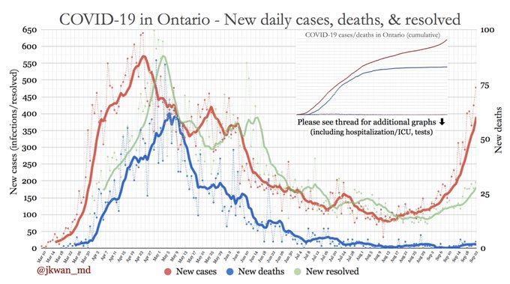

Graph: Dr. Jennifer Kwan, https://twitter.com/search?q=jennifer%20kwan&src=typed_query

The new test facing us is the increase in cases following Stage 3 relaxation of restrictions, the reopening of schools that began September 8, and the expected increase in cases in the fall and winter as we move into the cold and ‘flu season. While most university tuition is online, schools are open for in-person learning, with about 70% of families in Ontario opting for in-person schooling. This involves students congregating on transit, in daycares, classrooms and schoolyards. The Province’s plan does not reduce class sizes for elementary students and only allows for 1m distancing in elementary schools. Many schools are poorly ventilated. There is no physical distancing or number cap on school buses. Students are together in a confined space for hours, then return to their families. There is no semblance of “bubbles” for families with school-age children attending in-person public elementary schools, in particular.

Given that **the majority of the population is still non-immune**, and that there is now good evidence that children can transmit COVID-19, there is every reason to think that the current plan for school reopening will lead to a significant resurgence of infection in the Province, particularly in its largest city, Toronto. Numbers will most likely rise exponentially before they can be controlled again. This is already starting to be seen.

**Risk mitigation might be up to us**

Beyond the risk of a resurgence, we also face the risk that the Province may be reluctant to shut down the economy to the extent that was done in March. The calculus may shift to sacrificing some lives and some people’s health in the short-term, to minimize the long-term damage to people’s welfare if the economy is damaged too severely. Ideological choices may play into these decisions.

We are hoping that the response would be appropriate and we would simply be able to follow Public Health and Provincial recommendations. However, THS needs to be ready to react on our own if the official response, in our opinion, does not sufficiently mitigate risk to our staff and the THS community of foster parents, volunteers, supporters and adopters.

**Scenarios after schools re-open**

**Scenario One:** Best case. All goes well and case numbers increase slightly but not significantly. THS does not need to change its current services and processes.

**Scenario Two:** Case numbers rise moderately and the Province maintains current restrictions or moves back to Phase 2. The City may take similar measures if the Province does not. THS needs to scale back services and processes to keep people safe.

**Scenario Three:**  Worst case. Case numbers rise moderately to substantially and the Province moves back to Phase 1. The City may take some of these measures if the Province does not. THS needs to further scale back services and processes.

The likely time-frame for a rise in COVID-19 numbers would be 2-4 weeks after re-opening the schools. THS is well-positioned to adjust services and processes, based on our experiences of the past several months and our existing framework for expansion and contraction. The question is, when would we decide to scale back? What are the decision points?

**What has changed or is expected to change**

* Case numbers will be significantly higher than they were at the peak earlier in the year;
* Other respiratory viruses, particularly influenza, could exacerbate COVID-19 infections;
* Influenza infections will claim scarce hospital and ICU beds;
* Other respiratory infections are already driving a demand for testing and overwhelming testing capacity;
* There is a backlog in the health-care system and neglected conditions will become more urgent over time, affecting capacity. The same is likely to occur in veterinary medicine;
* The re-opening of the economy is driving new infections;
* The school reopening will rapidly drive increases in COVID-19 and other respiratory infections;
* The sense of unity that we had at the beginning of the pandemic has been eroded and a second lockdown may be more difficult to enforce;
* The economic consequences of the pandemic are severe and worsening, and will drive demand for our services at a time when we need to contract some of them again;
* Our ability to fundraise will be heavily impacted by the general damage to the economy. This means, more than ever, that every dollar counts.

**COVID-19 infection control and strategies**

Our general strategies (screening, physical distancing, mandated masks, hand hygiene and cultural change) do not need any overal adjustment but it would be very helpful to review how these are being executed on the ground and where improvements can be made.

For example:

* How time-consuming is the screening process and can it be made more efficient?
* Are staff distancing appropriately with trusted colleagues?
* Should we readjust rules for use of lunchrooms and washrooms?
* Can we improve ventilation in the highest-risk clinic spaces where people have to work closely together in small spaces? Are doors being kept open?
* Do we need to, and can we, address airflow any further in terms of our HVAC system?
* Educate staff about the importance of well-fitting masks .

**What programs and areas should we focus on expanding and supporting while we can?**

1. **Spay/neuter and TNR.** We should continue to run these surgeries for as long as we possibly can and attempt not to fully close them again. We should look at where the most urgent demand is and address this while we can. If we can focus appointments, to the extent possible, on where the impact will be highest, we should do so. We may need to review cohorts for our surgical staff.
2. **Megestrol acetate.** We did not pursue this oral contraceptive option for community cats earlier this year because of concerns about side effects, the negative impact this could have on relationships with colony caregivers, and in particular the concerns about adverse effects in pregnant cats. This time around we have time to educate caregivers, develop materials and institute a program for the late winter, before the breeding season starts again. The need is now also greater after an entire spring and summer with low TNR numbers, as cat numbers could increase exponentially next spring without intervention. Investigate demand and feasibility.
3. **Vaccination for juveniles and unprotected adults.** We should stop booking appointments for animals likely to have full protection against parvo, distemper and rabies, and book only for those that are unprotected. This applies to both public services and foster animals. This will help prevent outbreaks.
4. **Foster homes.** We should start prioritizing getting animals into foster homes again as a matter of urgency. Our capacity to keep animals in the shelter will drop quickly as we reduce numbers of staff coming in, and as staff become less and less willing to use transit to get to work because of perceived risks.
5. **Owned animal care.** The Fall wave lends more urgency to expanding our owned animal care services. Shelter capacity to house animals is likely to decline. There are also likely to be more owners unable to afford care so a greater demand for medical services or medical surrender. An incremental approach should be used.
6. **Training services.** It’s essential to continue to provide training for pet owners, but we should prioritize problem behaviours that might lead to relinquishment if not addressed.
7. **Staff updates and education.** Updates are being provided on a regular basis, as the status changes and/or new knowledge and developments arise.

**What metrics are we watching?**

Health Canada list a number of criteria and indicators for re-opening, which can also be reversed to help decide when it is not safe to reopen (see reference, “Guidance for a Strategic Approach…”). Many factors are listed, but those most relevant here are those relating to transmission. No actual numbers are provided.

Indicator 1.1: **Number of cases**, hospitalizations, intensive care unit (ICU) admissions and deaths per day. Comment – number of cases is our main indicator; hospitalizations and deaths lag new cases by approximately 2 weeks.  
Indicator 1.2: **Reproduction number**, **absolute and relative changes in cases**, hospitalizations and deaths. Comment – reproduction or Rt number and upward or downward trends are relevant to us in planning.

**Sources to monitor:**

* A very good and credible source of these statistics, and more, is the one provided by Ryan Imgrund, who is head of science at Sacred Heart Catholic High School in Newmarket, and hospital biostatistician at Southlake Regional Health Centre. I have not seen any other source like this. Mr. Imgrund publishes Ontario’s daily data on Twitter, at @imgrund. He contributed to the SickKids recommendations for school re-opening, and collaborates with epidemiologist Dr. David Fisman at U of T and others. The only problem with his data is that he keeps changing the metrics he calculates and displays so it’s difficult to track many of them consistently over time.
* Dr. Jennifer Kwan also publishes maps and data regularly on Twitter @jwan_md.
* The City of Toronto has a good COVID-19 monitoring dashboard here <https://www.toronto.ca/home/covid-19/covid-19-latest-city-of-toronto-news/covid-19-status-of-cases-in-toronto/>. All metrics on the dashboard were green August 11 when this section was started. Some of the dashboard is now orange and two metrics have moved to red (Sep 22).

Data is analyzed by (among other things) transmission rate (Rt), risk assessment (% risk of being exposed based on group size), rolling 14-day averages and trends, and how these trends relate to the stage and when the stage changed.

An example of the Imgrund statistics are shown in Appendix 16. The following table shows selected statistics for Toronto over time.

**Ryan Imgrund’s advice:**

* Rt always important, but check if the lower end of confidence interval is above 1.0 when cases are low (the confidence interval is the probably true range for a data point, calculated with 95% confidence).
* Rolling averages and hospitalization data are important, but lag. Important for deepening closures.
* Daily/weekly counts are useless for catching problems early.

|  |  |  |  |  |  |  |  |  |
| --- | --- | --- | --- | --- | --- | --- | --- | --- |
| **Statistic - Toronto** | **Sep 22**  **(60 days in Stage 3)** | **September 9 (40 days in Stage 3; schools o/s TDSB opened Sept 8)** | **August 11**  **(11 days into Stage 3)** | **July 31/Aug 1 (Last day of Stage 2)** | **July 21**  **(new metric added)** | **June 24**  **(first day of Stage 2)** | **June 6**  **(new metric added)** | **May 31**  **(first time data published)** |
| Stage | 3 | 3 | 3 | 2 | 2 | 2 | 1 | 1 |
| Rt (CI) | 1.33  (1.24-1.43) | 1.59  (1.45-1.74) | 1.1  (0.92-1.29) | 0.86  (0.73-1.01) | 1.03  (0.91-1.16) | 0.66  (0.6-0.72) | 0.93  (0.88-0.99) | 0.85  (0.8-0.9) |
| Weekly cases per 100,000 | 26 | 10 | 4 | 4 | 8 | 15 | 41 |  |
| 14-day COVID-19 rolling avg trend | +54% |  | -20%* | -43% | -41% | -65% |  |  |
| 10% chance of encountering a person transmitting COVID-19 if you see this # of people |  |  | 418 | 221 | 79 |  |  |  |
| Chance that at least one individual who can transmit COVID-19 is in a group of 25 | 5.0% |  | 0.6% | 1.2% | 2.6% |  |  |  |
| Chance that at least one individual who can transmit COVID-19 is in a group of 50 | 9.8% |  | 1.2% | 2.4% | 5.1% |  |  |  |

* % change from a small baseline is less significant than the same change from a large baseline

**How much risk is too much? How many cases are too many?**

This is a question we are not qualified to answer. However, this baseline data will help us monitor trends

# Phases and Subphases

**Phase 1: Expansion. Expand existing services that have continued in a modified form. Resumption. Resume high priority/low risk services. Contraction. Stop and slow services as flare-ups occur.**

**Phase 2: Resumption. Resume services that have been stopped or seriously curtailed. Staged based on a balance between priority and risk. Contraction. Stop and slow services as flare-ups occur.**

**Phase 3: Resilience. Regroup, protect our staff and organization for the long term. Re-imagine ourselves through lessons learned during COVID-19.**

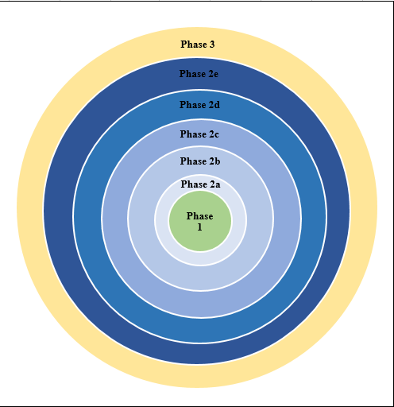

# Overarching Process And Protocol Adjustments

A number of processes and protocols apply to all aspects of functioning during the months ahead. These need to be in place in the relevant departments and physical areas as a prerequisite for opening certain services. Some of these are already in place and some need to be put in place, expanded or modified. Key operational areas are:

* Physical distancing
* Alternative service delivery
* Self-monitoring
* Personal protective equipment
* Cleaning and disinfection
* Response to an infected employee
* General infection prevention and control
* Communication with staff and the public

# Roadmap Planning Table: Overarching Changes

|  |  |  |
| --- | --- | --- |
| Operational area | Requirements | Notes |
| Physical adjustments e.g. plexiglass shields, signage, decals, floor tape | Determine what is needed in each area of the shelter  Order supplies and arrange instalment |  |
| Administrative adjustments | Determine which staff functions can continue to function virtually.  Determine which staff members who normally work on-site are high-risk, and re-purpose for off-site work. |  |
| Safe work practices | Screening at entry (staff and the public)  Teams  For each area of the shelter, determine staffing capacity based on 60ft2 per person  Avoid sharing workstations  Physically move people or functions if needed  Adjust use of shared space e.g. lunch room  Determine feasibility and detail of unidirectional flow through the building  Curbside transfer for shelter  Curbside transfer for shelter |  |
| Personal protective equipment and infection control | Update infection control protocol or infection control section of COVID-19 protocol – to include tables for which PPE is needed in which situations  Determine current stocks and anticipated needs |  |
| Automation and streamlining | Streamline current processes to allow (1) facilitate contactless processes; (2) increase time efficiency in the face of inevitably slower processes |  |
| Documentation | Plans and operational aspects must be easy to find and use |  |
| Training | Staff and volunteers need to understand purpose and operation of modified processes |  |

# Shelter Services and Programs – Phases and Stages

**Fall 2020 – we have put plans in place for the Contraction subphase. We are currently (September 29) viewing this largely as an adjustment and not yet a true contraction. We are committed to continuing as many key services as possible, for as long as possible, and expanding important virtual services.**

# Phase 1: Essential Services – Keep Open to Fullest Extent Possible

|  |  |  |
| --- | --- | --- |
| Department | Service | Notes Fall 2020 |
| Foster and Rescue Programs | Virtual Behaviour and Training |  |
| Telemedicine |  |
| Urgent Care Foster Support |  |
| Public Programs | Food Bank |  |
|  | | Pet/Guardian Parent Support Network |  |
| Public Veterinary Service | Euthanasia |  |
|  | | Preventive Wellness Telemedicine |  |
|  | | Shelter Outreach Telemedicine |  |
| Shelter | Foster Care |  |
| Animal Care |  |
| Behaviour and Training Support |  |
| Admissions, Urgent |  |
| Veterinary Care |  |
| Advancement and Research | | Shelter Advancement |  |

# Phase 2: Step-Wise Service Resumption or Contraction Based On Priority: Risk

## Phase 2A: High Priority, Low Risk

|  |  |  |
| --- | --- | --- |
| Department | Service | Notes Fall 2020 |
| Foster and Rescue Programs | Facilitated Adoption |  |
| Adopt from Foster |  |
| Shelter | Adoption - virtual |  |

## Phase 2B: High/Medium Priority, High/Medium Risk

|  |  |  |
| --- | --- | --- |
| Department | Service | Notes Fall 2020 |
| Foster and Rescue Programs | Behaviour and Training, In-person |  |
| Veterinary Care, In-person - urgent |  |
| Facilitated and Rescue Transport (to THS and to other locations) |  |
| Public Veterinary Service | Veterinary Care, In-person - urgent |  |
| Preventive Wellness, In-person - other |  |
| Shelter | Admissions, non-urgent, general |  |
| Admissions, non-urgent, healthy community cats |  |

## Phase 2C: High Priority, High Risk

|  |  |
| --- | --- |
|  |  |

|  |  |  |
| --- | --- | --- |
| Department | Service | Notes Fall 2020 |
| Public Programs | TNR |  |
| Social Exclusion (outreach trips, services) |  |
| Public Veterinary Service | Spay/Neuter (includes all, healthy and not healthy) |  |
| Expanded PVS services |  |
| Dental |  |

## Phase 2D: Medium Priority, Medium/High Risk

|  |  |  |
| --- | --- | --- |
| Department | Service | Notes Fall 2020 |
| Public Programs | Training and Behaviour 1-on-1 in-person |  |
|  | Dog-walking |  |

## Phase 2E: Low Priority, Medium/High Risk

|  |  |  |
| --- | --- | --- |
| Department | Service | Notes Fall, 2020 |
| Humane Education | Reading Buddies |  |
| Shelter Tours |
| In-classroom public school |  |
| Public Programs | Retail In-shelter |  |
| Training and Behaviour-in person training groups | This is important but lower priority at present given the risks. See task list re increasing remote and online training |
| Public Veterinary Service | HQHV Spay/Neuter | S/N is high priority but reinstating HV is lower priority at present given the risks. We have been able to continue this service using a low-volume model |
| Shelter | Adoption, onsite | Continue to hold for now. While adoptions are very high priority, they do not need to be on-site. |

# Phase 3: Resilience

**Resilience. Regroup, protect our staff and organization for the long term. Re-imagine ourselves through lessons learned during COVID-19.**

This will continue to be explored - plan for longer-term adjustments based on what we have learned from the pandemic and on anticipated economic challenges going forward.

# Appendix 1: NACA Recommendations For Continued Modified Operations Due to COVID-19

<https://www.nacanet.org/wp-content/uploads/2020/05/NACA-Recommendations-for-Continued-Modified-Operations-Due-to-COVID-19.pdf>

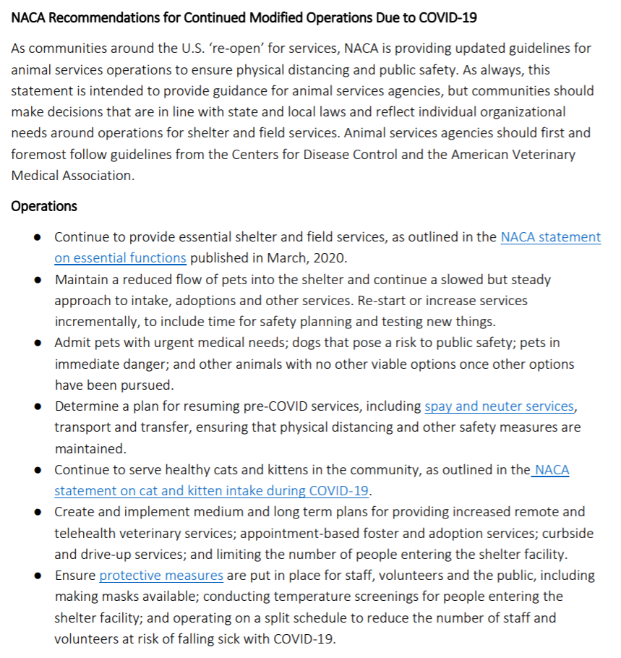

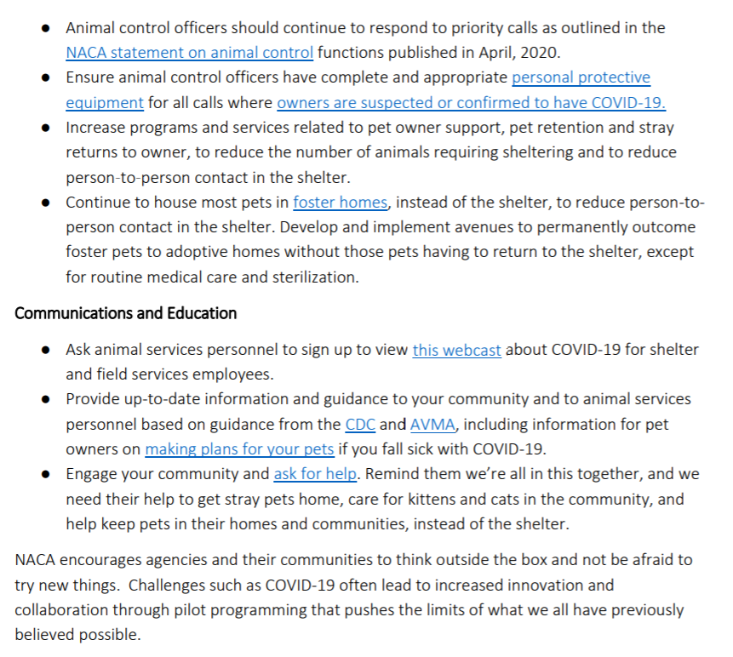

# Appendix 2: College of Veterinarians of Ontario - Risk-Based Approach To Decision-Making In The COVID-19 Environment

<https://cvo.org/getmedia/df091058-d703-42b4-aef3-58358d7d172c/riskchartFINAL.pdf.aspx>

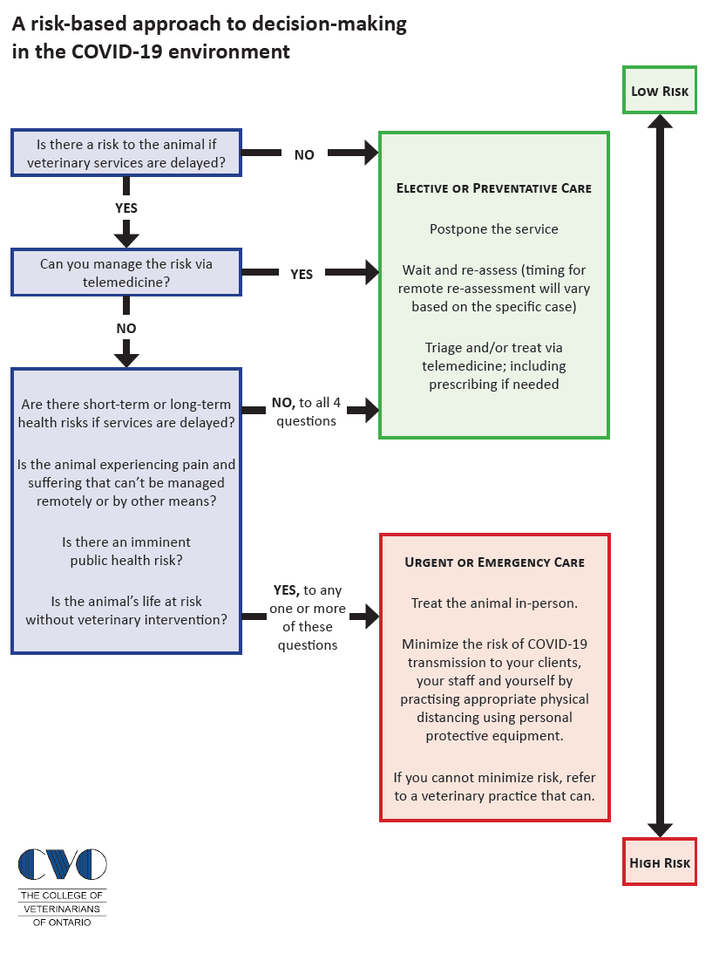

# Appendix 3: Ontario Veterinary Medical Association COVID-19 Guide for Practices (April 17)

<https://www.ovma.org/assets/1/6/COVID_guide_for_practices_revised_April_17.pdf>

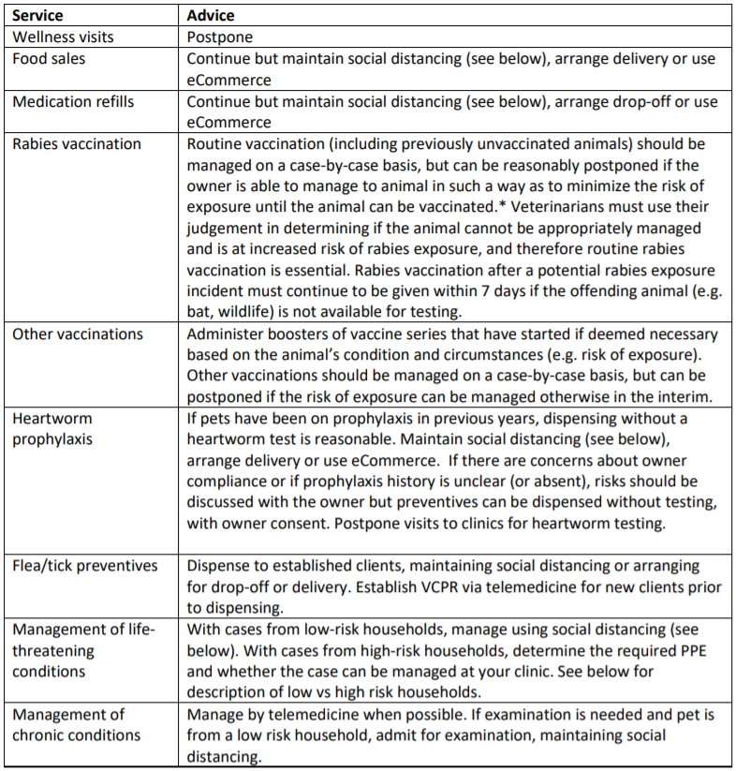

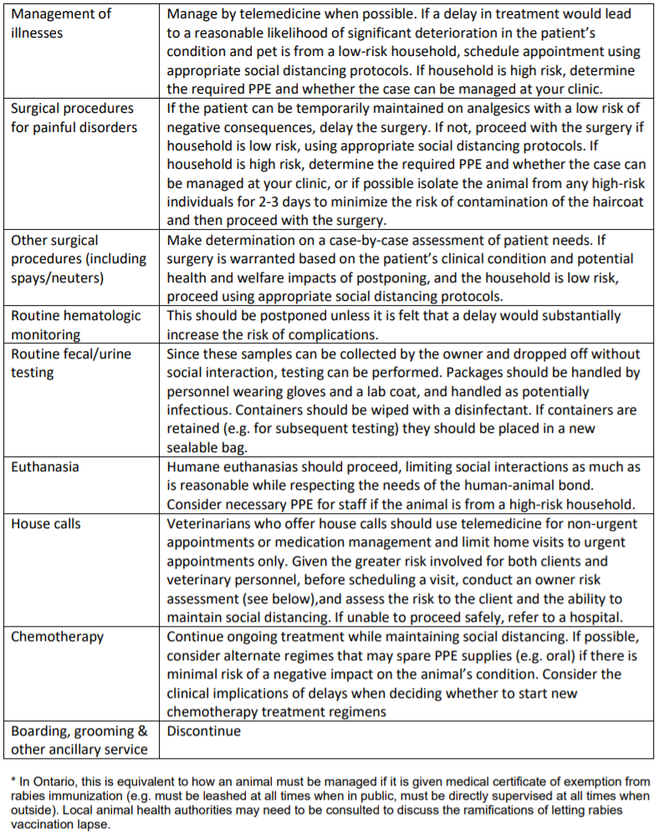

# Appendix 4: Owner Contact Guidelines

<https://www.wormsandgermsblog.com/files/2020/04/DT_Covid2019_03302020_G-copy.png>

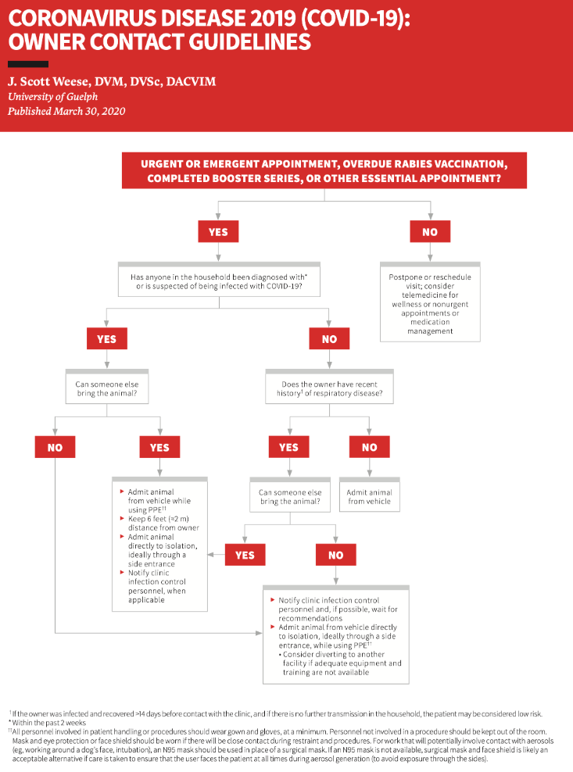

# Appendix 5: CVO Guidance For Ontario Veterinarians – Selected CVO Updates

* **How to document consent without a signature: Acceptable during the pandemic: A note that the owner of the animal or a person on the owner’s behalf consented orally to the surgical treatment, and the reason why the consent was not in writing.** <https://cvo.org/getmedia/06f59919-99e7-4627-a3d5-1899aa37ad6a/CoronavirusMarch172020signatures.pdf.aspx>
* **Dispending and prescribing through telemedicine:** <https://cvo.org/getmedia/c1132067-5181-49a2-b450-fd4b63ff118d/CoronavirusMarch182020urgentnoticeprescribingdispensing.pdf.aspx>
* **Veterinary services are essential, but urgent care only (April 3)** <https://cvo.org/getmedia/72e830dc-9ccf-4a3e-bceb-3e378c80ec82/CoronavirusUrgentOnlyCare.pdf.aspx>
* **Determining what is urgent:** No laundry lists. “How might you justify your decisions to a group of your peers?” Balance animal, context, competence, public safety and staff safety.
  + <https://cvo.org/getmedia/b0b68f30-a8ab-45a4-96b6-a99da66e70e9/Coronavirusclarificationonurgent.pdf.aspx>
  + <https://cvo.org/getmedia/d7895e7f-e98b-4ac7-b3fd-1f10b66865eb/Coronavirusriskbaseddecisiontool.pdf.aspx>
* **Prioritizing cases and making decisions:** <https://cvo.org/getmedia/d7895e7f-e98b-4ac7-b3fd-1f10b66865eb/Coronavirusriskbaseddecisiontool.pdf.aspx>

“Please be assured the College is aware that these are unusual times. You must depart from your established procedures. Do know that any concerns brought to our attention at this time will always rely on facts but also on the realities of delivering care during a public health emergency.”

* **Premier’s announcement concerning veterinary medicine May 14, 2020 (summary)**

Businesses that provide veterinary services can begin providing regular veterinary appointments on **May 19, 2020**. This announcement removes the directive that only permitted the delivery of urgent veterinary services.

The province **remains in a public health emergenc**y and veterinarians, as public health practitioners, are advised to continue to engage in public health measures which decrease the potential for exposure to COVID-19. In determining services to be delivered, a veterinarian must use their judgment with consideration to the animal, the context, their competence, public safety and staff safety. ***Veterinarians have a responsibility to society to deliver services in a manner that decreases COVID-19 exposure.***

***Telemedicine:*** No change to existing emergency notice.

***Moving forward:*** Again, we stress that veterinarians follow all public health recommendations, be innovative in your care delivery and make smart choices in deciding which services you can safely deliver. When you do provide in-person care to an animal, be attentive to public health recommendations and your infection control and biosecurity protocols to safeguard employees, clients and animals.

# Appendix 6: Spay/Neuter Self-Assessment Checklist

<https://www.animalsheltering.org/sites/default/files/2020-05/Spay%20Neuter%20Assessment%20Checklist.pdf>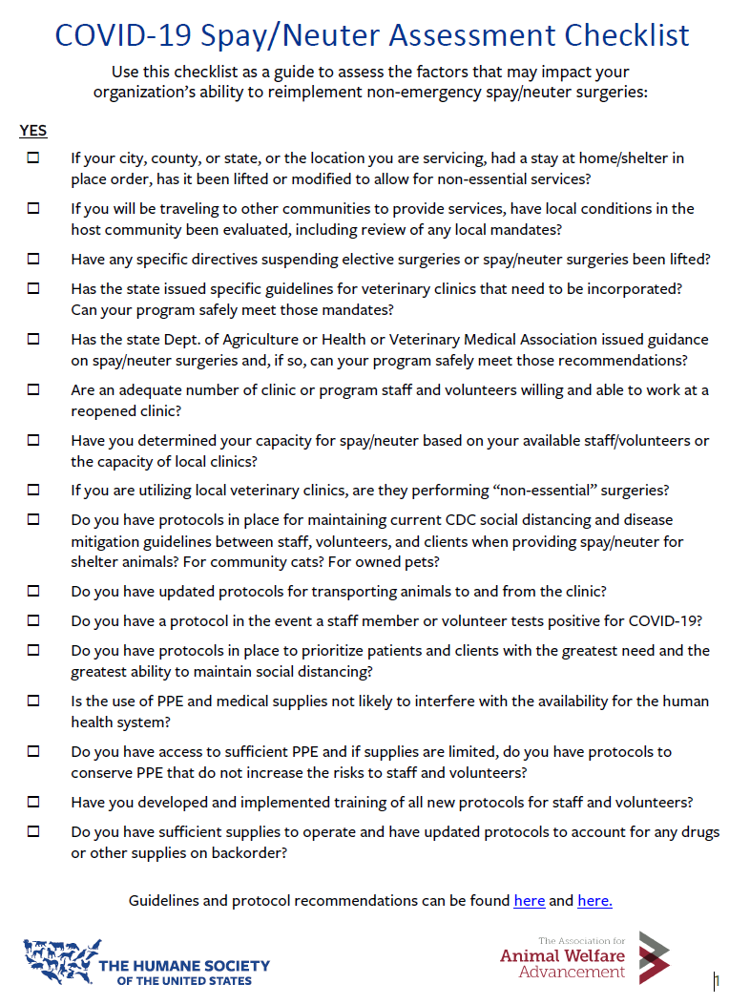

# Appendix 7: Example Of A Morning Check-List

<https://www.dropbox.com/s/sac3rfpcsz4jho5/SAMPLE-Surgical%20Team%20AM%20Checklist.pdf?dl=0> within

<https://network.bestfriends.org/covid-19-sn-clinic-guide>

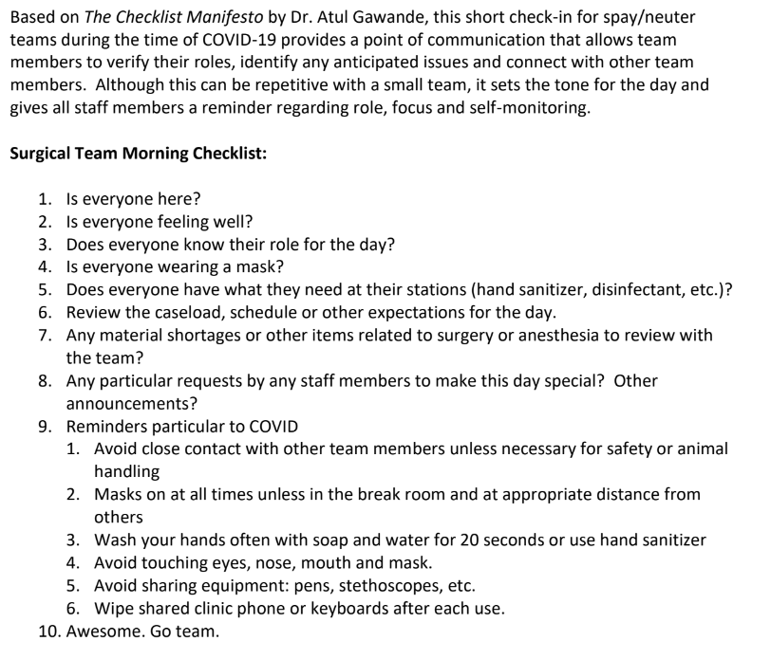

# Appendix 8: Staff Survey - Example

<https://www.dropbox.com/s/kkm56r0624nhau3/SAMPLE_%20Staff%20Capacity%20Survey%20.pdf?dl=0> link from <https://network.bestfriends.org/covid-19-sn-clinic-guide>

don’t love this, what about risk factors??

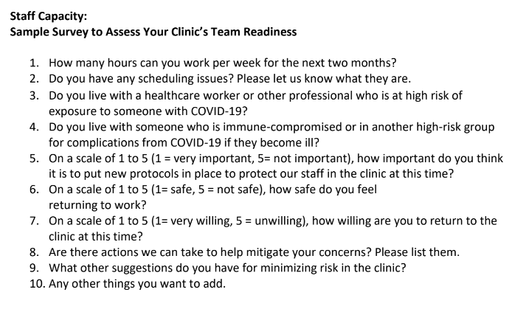

# Appendix 9: Examples Of Signage

Downloadable, from links in <https://network.bestfriends.org/covid-19-sn-clinic-guide>

<https://www.dropbox.com/s/ycbaz56y56uwycm/SAMPLE_%20Communications%20SNAP%20Covid-19_Protocol%20Client%20Sign.pdf?dl=0>

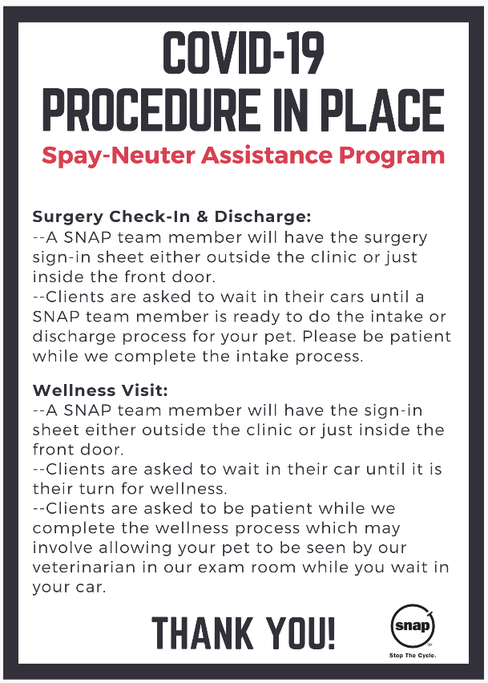

<https://www.dropbox.com/s/7qqro5ymwand88v/SAMPLE_%20CommunicationsSNAP%20Covid-19_Social_Distancing%20Sign.pdf?dl=0>

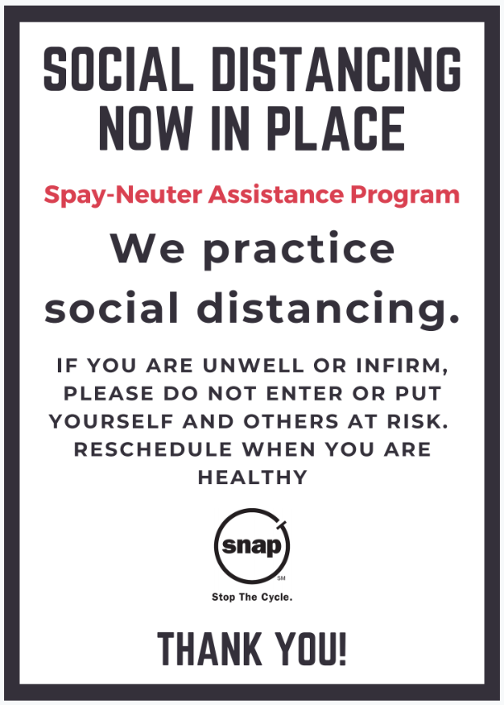

<https://www.dropbox.com/s/b6bg4tcrw4cprbg/Sample_%20CommunicationsSNAP%20We%20Are%20Open%20Sign%20-%20COVID%20Essential_Business.pdf?dl=0>

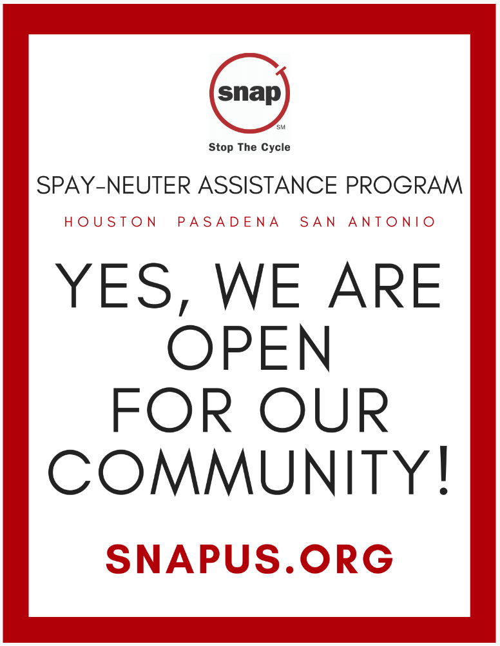

Add gentle local humour to messaging

<https://www.theguardian.com/lifeandstyle/2020/may/11/stay-four-koalas-apart-an-animal-hospitals-response-to-coronavirus-in-pictures?CMP=Share_iOSApp_Other>

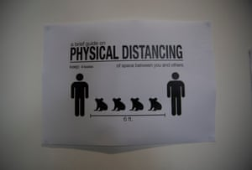

# Appendix 10: FAQ For Clients (Partially Reproduced Below)

from <https://network.bestfriends.org/covid-19-sn-clinic-guide>; in <https://www.dropbox.com/s/ta7lzbuae8v8wo0/SAMPLE_%20FAQ.pdf?dl=0>

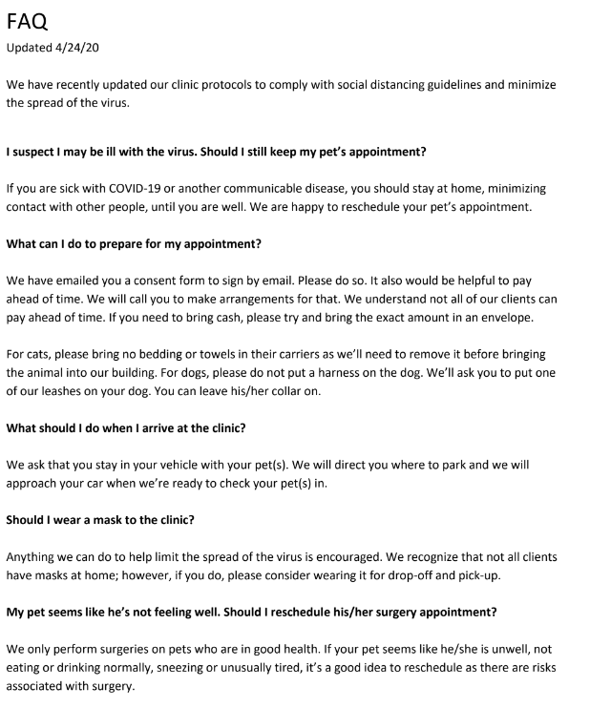

# Appendix 11: Suggested Approach to Use of PPE.

Each clinic should develop and post tables appropriate to its specific needs.

<https://www.ovma.org/assets/1/6/Practice_Reopening_Guide.pdf>

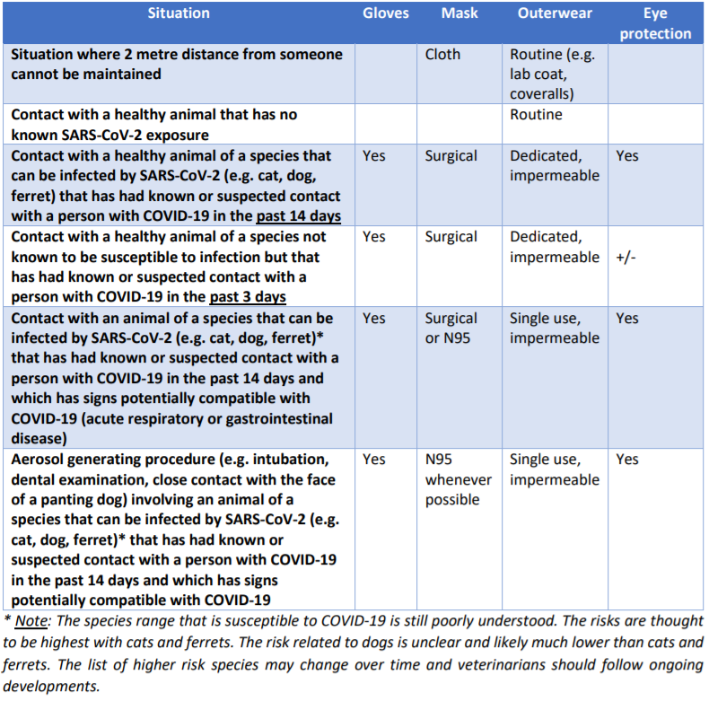

# Appendix 12: Building A Plan To Re-Open

<https://www.maddiesfund.org/covid-19-spay-neuter-and-vaccine-clinic-preparedness-guide.htm>

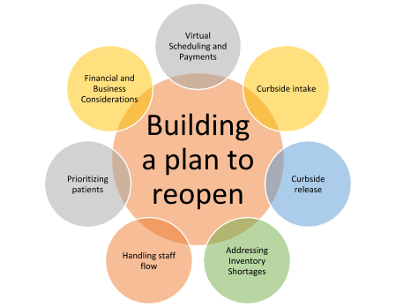

# Appendix 13: The Future Is Here: Ten Steps Shelters Can Take Now To Build Better Animal Services

<https://americanpetsalive.org/blog/the-future-is-here-ten-steps-shelters-can-take-now-to-build-better-animal-services>

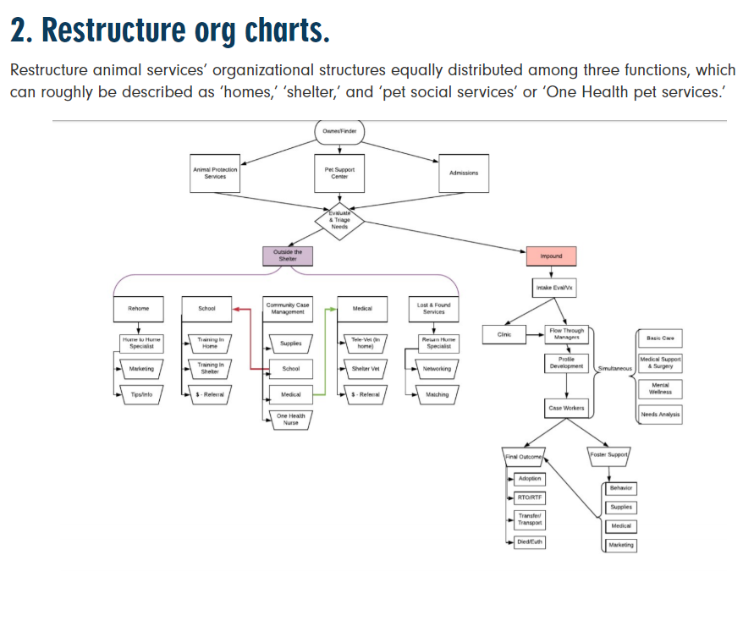

# Appendix 14: Provincial Government Lifts Urgent Care Provision For Veterinary Services (May 14)

OVMA E-Newsletter

On May 14, Premier Doug Ford announced the next set of businesses allowed to reopen under the provincial government’s Reopening After COVID-19 framework. As part of that announcement, the province removed the “urgent care only” limitation on veterinary services and has allowed pet groomers to open (by appointment only), effective Tuesday, May 19. As of that date, veterinary practices will be able to offer a full range of services, including preventive care. The extent to which practices choose to expand the services they offer as of May 19 will be up to each individual practice to determine.

**As veterinary practices contemplate expanding the range of services offered, they are reminded that social distancing measures are still in effect.** Effective implementation of such measures will be essential to ensuring that employees feel comfortable working in the practice as it expands its service offerings. Practice owners and managers are encouraged to work with their staff to implement protocols to protect the health and safety of both employees and clients. To assist in that regard, OVMA has worked with Dr. Scott Weese to develop [A Guide to Reopening Veterinary Medicine in Ontario](https://can01.safelinks.protection.outlook.com/?url=https%3A%2F%2Fonline.ovma.org%2Fovmassa%2Fecmssamsganalytics.click_through%3Fp_mail_id%3DE58117A983691B1C186900&data=01%7C01%7Cljacobson%40torontohumanesociety.com%7C241d612a360f45c787a908d7f83995f0%7C7a38f7d4c7e14d66a7c3d39ea5e5e735%7C1&sdata=shflx6Ccp2xeuDGPzqD5djmlXP%2Bk%2Fuu7wYPfhoLVcrw%3D&reserved=0). Members may also want to check out OVMA's webinar recording on [Strategies for Dealing with Post-COVID Clients, Finances and Production](https://can01.safelinks.protection.outlook.com/?url=https%3A%2F%2Fonline.ovma.org%2Fovmassa%2Fecmssamsganalytics.click_through%3Fp_mail_id%3DE58117A983691B1C186901&data=01%7C01%7Cljacobson%40torontohumanesociety.com%7C241d612a360f45c787a908d7f83995f0%7C7a38f7d4c7e14d66a7c3d39ea5e5e735%7C1&sdata=6oZw0eYOcXNgt2aYYkAD5r9Eizn5pECuc7q4jN5PIhM%3D&reserved=0).

OVMA has been in communication with the College of Veterinarians of Ontario and the Ontario Association of Veterinary Technicians throughout this pandemic. All three organizations have shared member concerns, stories, struggles and triumphs. We would like to extend our heartfelt thanks and commendation to Ontario's veterinary teams over the last two months. You have continually been thrown new challenges and reintegrating non-urgent care into practice is yet another one. We hope that veterinarians, registered veterinary technicians and the whole veterinary team can continue to work cooperatively to adapt once again as the province reopens.

If you have any questions about the reopening framework in Ontario, contact Brandi Deimling at [bdeimling@ovma.org](https://can01.safelinks.protection.outlook.com/?url=https%3A%2F%2Fonline.ovma.org%2Fovmassa%2Fecmssamsganalytics.click_through%3Fp_mail_id%3DE58117A983691B1C186902&data=01%7C01%7Cljacobson%40torontohumanesociety.com%7C241d612a360f45c787a908d7f83995f0%7C7a38f7d4c7e14d66a7c3d39ea5e5e735%7C1&sdata=6eVf8hfdnhsHzgwEpDXGVTOgUf7afq3jq27Z4y2Q1E8%3D&reserved=0).

# Appendix 15: Key Points - Ontario Workplace Safety and Prevention Services Guidance for Veterinary Clinics

<https://www.wsps.ca/WSPS/media/Site/Resources/Downloads/covid-19-veterinary-health-and-safety-guidance.pdf?ext=.pdf>

**Notes:** Extracts of the document are copied below; this is not the complete document.

KEEP INFORMED AND COMMUNICATE

* Update the business’s voicemail, email, social media, website and other external communications, and create a visible sign for your door to inform customers of changes to the business operations.
* Screen customers and staff regularly for health issues. This may include reminders to customers on websites and via telephone messages. If anyone develops symptoms of COVID-19, implement procedures for reporting the illness and keeping the worker away from others.
* Ensure that illness reporting requirements are well communicated in the workplace through training and signage. People who are sick or have signs of illness (e.g. fever, coughing, sneezing, runny nose, tiredness, shortness of breath) must self-isolate, notify their employer and call a doctor or healthcare provider.
* Train workers on where COVID-19 transmission points may exist within the workplace, steps being taken to protect them from the virus and how they can protect themselves (including frequent hand washing or sanitizing, and not touching their face with unwashed hands).

ELIMINATE OR MINIMIZE EXPOSURE

* Provide hand sanitizer or sanitizing wipes for customers to use if entry is required. Consider having them available near the entryway, waiting areas, at reception and other high-traffic areas. Have a safe place for proper disposal of wipes. Empty and clean waste containers on a regular basis.
* Consider ways to minimize contact between workers and pet owners during drop off and pick up, and inform customers of safe work practices: o Establish clear visuals to show where the designated pickup area is located and the boundaries of the pickup area
  + Have customers schedule and call first before picking up and dropping off
  + Consider having workers assigned their own pet leashes/leads and inform customers that their leads and other items such as pet clothes, harnesses, etc. will not be permitted to remain in the workplace.
* Where necessary, permit a maximum of one healthy adult to accompany the pet to a medical visit and for that person to wait in a designated area or their vehicle. Ask for verbal or electronic consent rather than requiring signatures on any authorization documents.

PHYSICAL DISTANCING

* Do not permit customers to hold animals during an exam or other procedures. Where possible, safely restrain the animal to avoid having multiple workers working in close proximity to complete grooming or other services.
* Install physical distancing markers throughout the reception area and other areas depending on the size of the facility, including the entrance area outside the premises if appropriate, to ensure customers maintain physical distance of 2 metres.

DISINFECTING AND SANITIZING

* Consider having disinfecting wipes and sanitizer at key areas for your workers, including their workstations. Provide a safe place for individuals to dispose of used sanitizing wipes and personal protective equipment. Empty and clean waste containers on a regular basis.
* Clean and disinfect all areas, instruments and equipment, including leashes/leads, grooming tools, tables, floors, etc. between each appointment.
* Main entrance area including door handles and counters need to be sanitized with each entry or exit.
* Where possible, assign a worker to ensure staff and customers are utilizing sanitizing materials, following physical distancing protocols and screening for customers presenting COVID-19 related symptoms.

OTHER CONTROL MEASURES

* Pursuant to public health advice, cloth masks must be worn by workers to prevent droplet transmission from worker to patrons.
* Use high-efficiency particulate air (HEPA) filters in the ventilation system, increase fresh air intake, and open doors and windows where possible.

# Appendix 16: Toronto’s COVID-19 Status and Risks

<https://twitter.com/imgrund/status/1293171004290859008> (August 11, 2020)

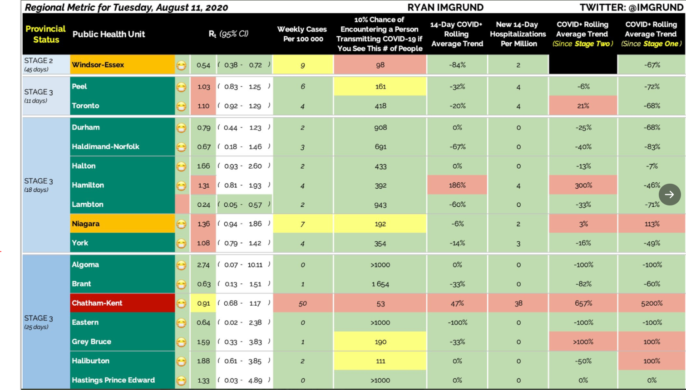

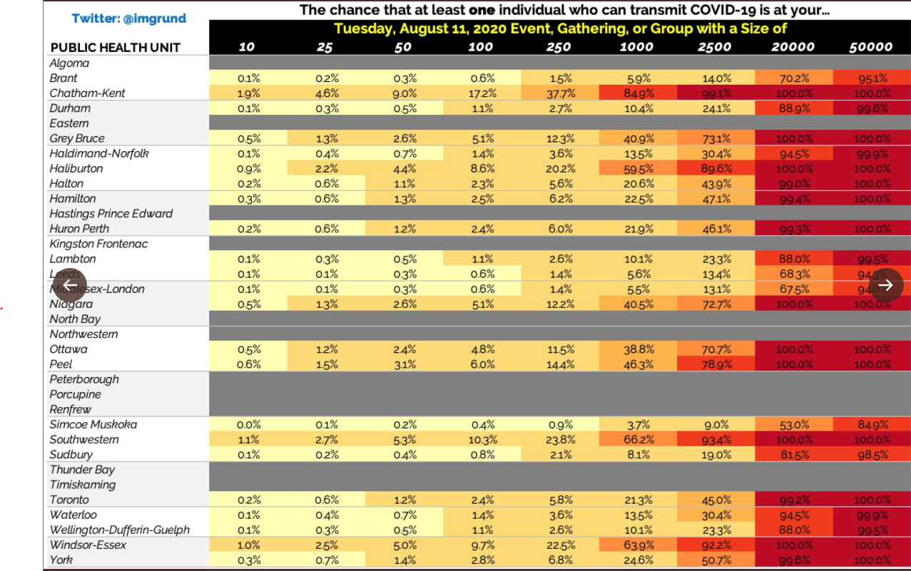

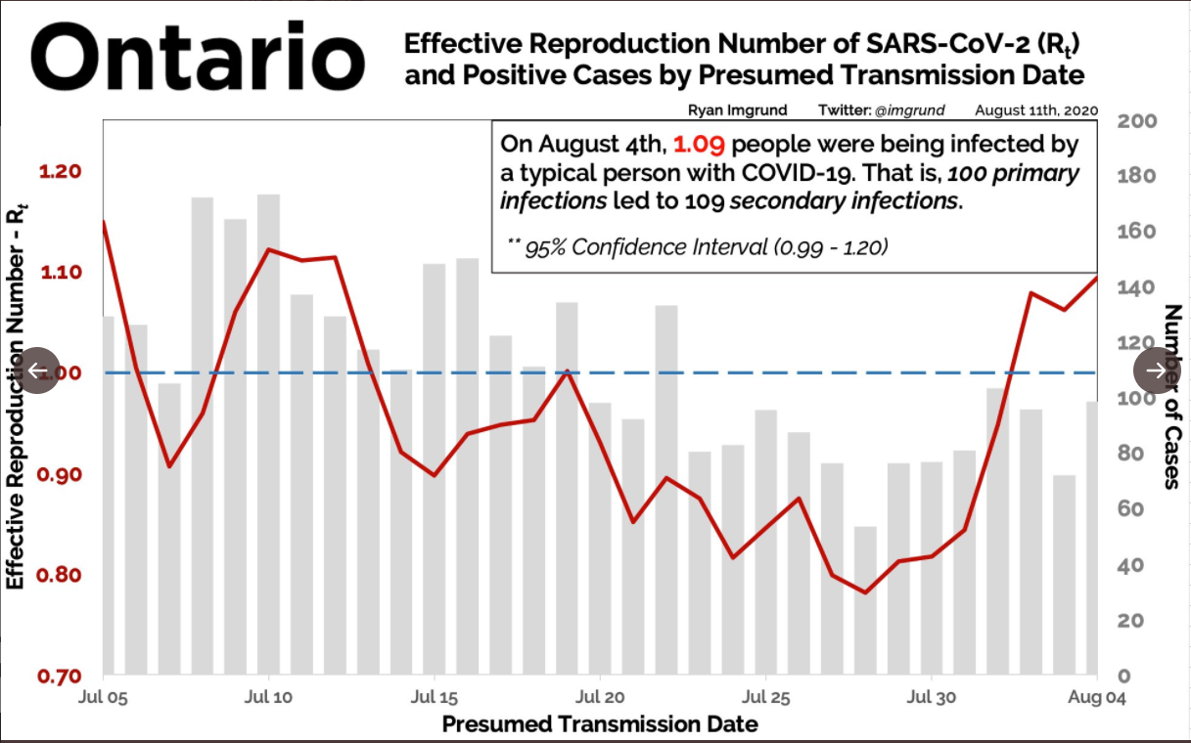

# Key Resources

**Amid the Coronavirus Crisis, a Regimen for Re-entry**

[https://www.newyorker.com/science/medical-dispatch/amid-the-coronavirus-crisis-a-regimen-for-reentry](https://www.newyorker.com/science/medical-dispatch/amid-the-coronavirus-crisis-a-regimen-for-reentry%20%5b28)

**COVID-19 Resources for Canadian Animal Shelters**

<https://humanecanada.ca/our-work/covid19-for-shelters/>

**COVID-19 – What We Know So Far About… Routes of Transmission**

<https://www.publichealthontario.ca/-/media/documents/ncov/wwksf-routes-transmission-mar-06-2020.pdf?la=en> [28 April, 2020]

**Physical Distancing, Face Masks, And Eye Protection To Prevent Person-to-person Transmission Of Sars-cov-2 And Covid-19: A Systematic Review And Meta-analysis**

<https://www.thelancet.com/journals/lancet/article/PIIS0140-6736(20)31142-9/fulltext>

**Ontario Veterinary Medical Association COVID-19 Guide for Practices (April 17)**

<https://www.ovma.org/assets/1/6/COVID_guide_for_practices_revised_April_17.pdf>

**Ontario Veterinary Medical Association checklist**

<https://www.ovma.org/assets/1/6/eNews_2020_NewsHound_March-16-Final.pdf>

**College of Veterinarians Updates and Guidance**

[See](https://cvo.org/getmedia/66d2c427-1ac3-4750-890f-7a134a124297/CoronavirusMitigateRisk.pdf.aspx) bulleted text in document for specific links

**College of Veterinarians of Ontario - Risk-based approach to decision-making in the COVID-19 environment (see Appendix)**

<https://cvo.org/getmedia/df091058-d703-42b4-aef3-58358d7d172c/riskchartFINAL.pdf.aspx>

**Community-based measures to mitigate the spread of coronavirus disease (COVID-19) in Canada [page is archived and under review but is still a useful resource]**

<https://www.canada.ca/en/public-health/services/diseases/2019-novel-coronavirus-infection/health-professionals/public-health-measures-mitigate-covid-19.html>

**Spay/Neuter Self-Assessment Checklist**

<https://www.animalsheltering.org/sites/default/files/2020-05/Spay%20Neuter%20Assessment%20Checklist.pdf>

**COVID-19 Spay/Neuter and Wellness Clinic Preparedness Guide**

<https://network.bestfriends.org/covid-19-sn-clinic-guide>

**NACA Recommendations for Continued Modified Operations**

<https://www.nacanet.org/wp-content/uploads/2020/05/NACA-Recommendations-for-Continued-Modified-Operations-Due-to-COVID-19.pdf>

**Neighborhood Cats: COVID Resources for TNR and Community Cats**

<https://www.neighborhoodcats.org/covid-19>

**COVID-19: A Guide to Reopening Veterinary Medicine in Ontario, Stage 2 (June 10, 2020)**

<https://www.ovma.org/assets/1/6/Practice_Reopening_Guideline_-_Stage_2_(June_10).pdf>

**COVID-19: A Guide to Reopening Veterinary Medicine in Ontario (April 17, 2020)**

<https://www.ovma.org/assets/1/6/Practice_Reopening_Guide.pdf>

**Sector-Specific Guidelines Ontario Businesses Need To Consider Before Reopening**

<https://toronto.ctvnews.ca/sector-specific-guidelines-ontario-businesses-need-to-consider-before-reopening-1.4919765>

**Ontario Framework for Reopening the Province**

<https://files.ontario.ca/mof-framework-for-reopening-our-province-en-2020-04-27.pdf>

**Ontario Re-Opening Stages, Regional Re-Opening to Stage 2 (June 8)**

<https://www.ontario.ca/page/reopening-ontario-whats-each-stage>

**Coronavirus Disease (Covid-19) Advice For The Public – Downloadable Posters**

<https://www.who.int/emergencies/diseases/novel-coronavirus-2019/advice-for-public>

**Occupational Safety and Health Act Guidelines on Preparing Workplaces for COVID-19**

<https://www.osha.gov/Publications/OSHA3990.pdf>

**CDC Guidance for Veterinarians During the COVID-19 Response**

<https://www.cdc.gov/coronavirus/2019-ncov/community/veterinarians.html>

**The Future is here: Ten steps shelters can take to build better animal services**

<https://americanpetsalive.org/blog/the-future-is-here-ten-steps-shelters-can-take-now-to-build-better-animal-services>

**Workplace Safety & Prevention Services: Guidance on Health and Safety For Veterinary Services (Pet Groomers/ Dog Walkers/ Pet Boarding/ Animal Care Providers) during COVID-19**

<https://www.wsps.ca/WSPS/media/Site/Resources/Downloads/covid-19-veterinary-health-and-safety-guidance.pdf?ext=.pdf>

**Guidance for a strategic approach to lifting restrictive public health measures**

<https://www.canada.ca/en/public-health/services/diseases/2019-novel-coronavirus-infection/guidance-documents/lifting-public-health-measures.html>

**FAQs on Protecting Yourself from COVID-19 Aerosol Transmission**

<https://docs.google.com/document/d/1fB5pysccOHvxphpTmCG_TGdytavMmc1cUumn8m0pwzo/mobilebasic#h.guml01vbysm4>